Level 3: Mathematical Modelling lesson seeds

Theme: Active communities
Victorian Curriculum 2.0 Content Description

use mathematical modelling to solve practical problems involving additive and multiplicative situations, including financial contexts; formulate problems using number sentences and choose calculation strategies, using digital tools where appropriate; interpret and communicate solutions in terms of the situation VC2M3N08

Teaching context
At Level 3, students can draw on the mathematical ideas, processes and experiences they have learned across Levels F-2.
Many schools engage upper primary students in thinking about enterprise and entrepreneurship by involving them in planning, budgeting for, and operating market stalls where goods and services are priced for profit. With the right choice of context, these important financial concepts can be introduced at a young age. The Lolly Pop task and the Active Play task do this through simple, relatable situations involve making simple financial plans.
You might vary aspects of the tasks to make them more challenging – for example, by selling items that are harder to price (like lolly bags) or by assigning a higher budget. Engage students in conversations about brands, quality, price, and value for money. This lesson seed can be extended over more than 1 lesson. (and most likely will need to be)

Important background to consider prior to the lesson
As there is more than one possible solution to each task, students should be encouraged to discuss their mathematical thinking and workings with each other.
Work through each task yourself before implementation so that you anticipate questions students may have about the context, what approaches they might take, and possible materials needed.
Start with a discussion about the context. The aim of the discussion is to help students access the task and help you to identify what support they may need.

Important messaging for students
Identify the relevant key points for your planning to facilitate dialogue with your class during the lessons. You might use these as dialogue prompts, enabling and extending prompts or reflection tools.
- Maths can help us solve real-life problems
- Real-life problems can be messy and can have more than one solution
- Working with others is important to gain ideas and understanding to solve real-world problems
- Talking about real-life problems helps us understand our world
- It’s a good idea to make a plan when doing mathematical modelling and adjust
- We make decisions about the maths that we need to solve the problem, and often need to try different approaches
- We can solve problems in different ways, using materials, visuals, diagrams, words and symbols to explain our thinking
- We make choices and justify them when we solve real-life problems
- It’s important to show and explain our thinking to communicate our ideas
- Solving real-life problems is part of mathematics and is interesting and engages our minds!

The lolly pop fundraiser task
Use this lesson seed to structure the lesson to enable all students to engage in planning, decision making, justification and communication of ideas. Provide materials that will enable students to explore their thinking (e.g., whiteboards, paper, manipulatives, calculators)
Some (but certainly not all) students will have bought and sold items as part of community fundraisers.
The opening discussion should enable all students to gain familiarity with fundraising.
- Ask students to think about similar personal experiences.
- Have they have seen chocolate fundraising boxes at their childcare centre, kindergarten or sporting club?
Explain the situation
Your class is going to contribute to the school fundraiser.
Together, your class decides to invest in lolly pops. You can buy 100 lolly pops for $30.
Pose the following questions
- What would be a fair price to sell each Lolly Pops for?
- How much money will the class make?
Once the class has discussed this task, extend the problem by selection from these prompts (or use your own)
- Will 100 lolly pops be enough for our school? How can you decide?
(size of school, other products might be some of the considerations)
- What would happen to the profits if we only sold half of the supply?
Active Play task
Some (but certainly not all) students will have helped their school raise money for special purchases.
An opening discussion should enable all students to gain familiarity with researching spending decisions and budgeting. Do they know about community grants or voucher programs that help schools and clubs buy new sporting equipment? Draw on a local context to explain where the school/club has raised money for a specific purpose.
Explain the situation
Your sporting club has a budget of $500 to buy new sporting equipment.
Once students understand the task, then scaffold as needed (e.g., demonstrate the use an internet search engine for this purpose)
- Research the prices of sporting goods online.
- Create a poster communicating what your sporting club can afford to buy with $500.
- Include a written recommendation that explains what the best value for money is for your proposal
The Steve Moneghetti Track task
The context for this mathematical modelling task is a track around Lake Wendouree in Ballarat.
Ensure all students have at least some understanding of the context (additional understanding is likely to occur when solving the task).
Discussion prompts can include:
- Who knows what a lake is?
- What is a track? What is a track used for?
- Has anyone ever walked or run or cycled along a track?
- How might a lake track be different to other tracks?
- Who is Steve Moneghetti and why has a track been named in his honour?
(named in honour of Ballarat marathon runner and Olympian)
Display the following images of this sign and facilitate dialogue for this prompt to introduce the task:
- Here are two views of the same sign (front and back). What do you notice?
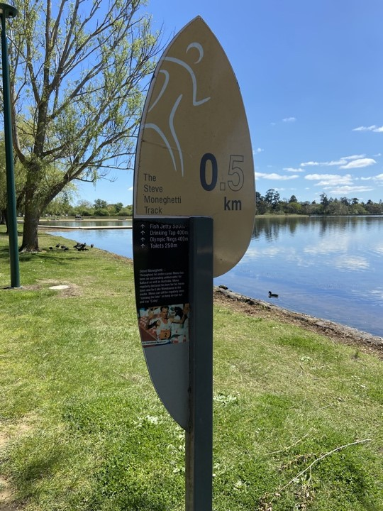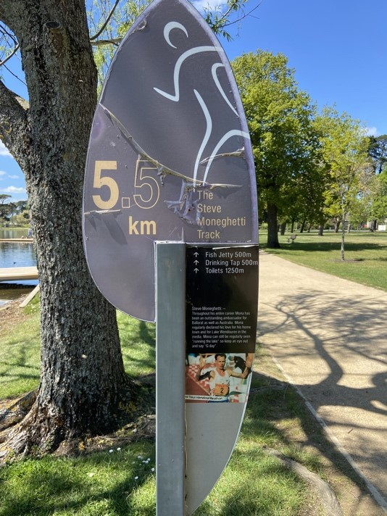
Photos provided by author (Jill Brown, 2025)

Explain the task
Ballarat City Council (the local Council) has decided the signs on the track need to be upgraded. They need your help to determine how many signs are needed and what key information will be recorded on each sign.
Work in pairs to solve the problem.
Use words and diagrams to explain your solution to the local Council in the form of a letter.
Additional resources for this task
RunGo | Steve Moneghetti Track - Lake Wendouree | Lake Wendouree
Moneghetti's track set to light up after 15 years of campaigning - ABC News

